*Term Project*

*CSD 4464_3 2023 W*

*Instructor: Faisal Khan*

|  |  |  |
| --- | --- | --- |
| *Name* | *Student ID* | *Group#* |
| *Anjali Chaudhari* | *C0853334* | *CSAT_3* |
| *Kavan Patel* | *C0843282* | *CSAT_3* |
| *Harsh Patel* | *C0850579* | *CSAT_3* |
| *Krunal Patel* | *C0849574* | *CSAT_3* |
| *Manthan Kotadia* | *C0853905* | *CSAT_3* |

1-Use Documentation Comments where needed and use Javadoc to create HTML files for documentation.

2-In your project src folder add this word document with all your group members names and paste the screen shots of your output after each question.

3-Right Click on your Project Folder in Eclipse, Copy Option is available. Create a copy of the Project and upload the zipped folder using Moodle.

Create a web based application using Either JSF or JSPs & Servlets in BootStrap. Your web application should maintain

A Tax Filing Company Records. You can use a model class

Tax_Filers with fields like.

**FilerID,Name,Contact,AnnualIncome,Expenses,TaxYear**,

**DateFiled**

You should be able to perform all these CRUD Operations.

a)Create a Database FilersRecord for your application.

Create a table named TaxFilers in this database.

Insert 5 to 6 Records in this table. 10

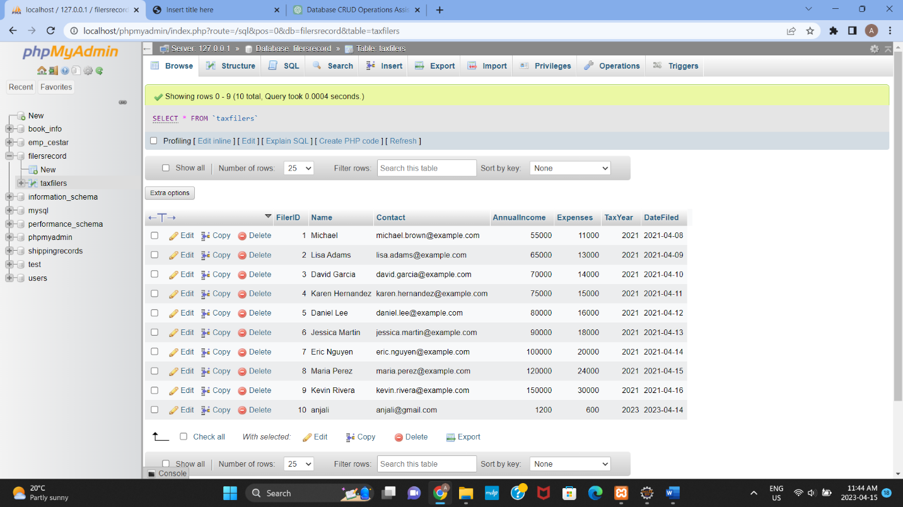

b) Display all the TaxFiler Records in your xhtml page View or a JSP page as a table.

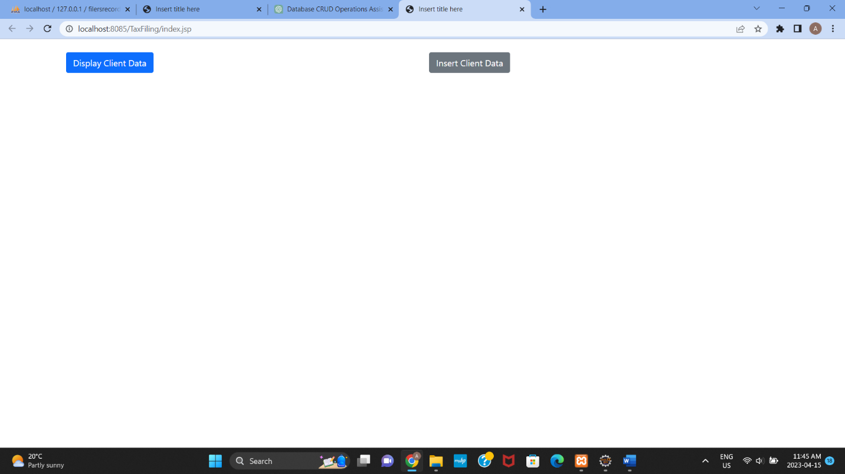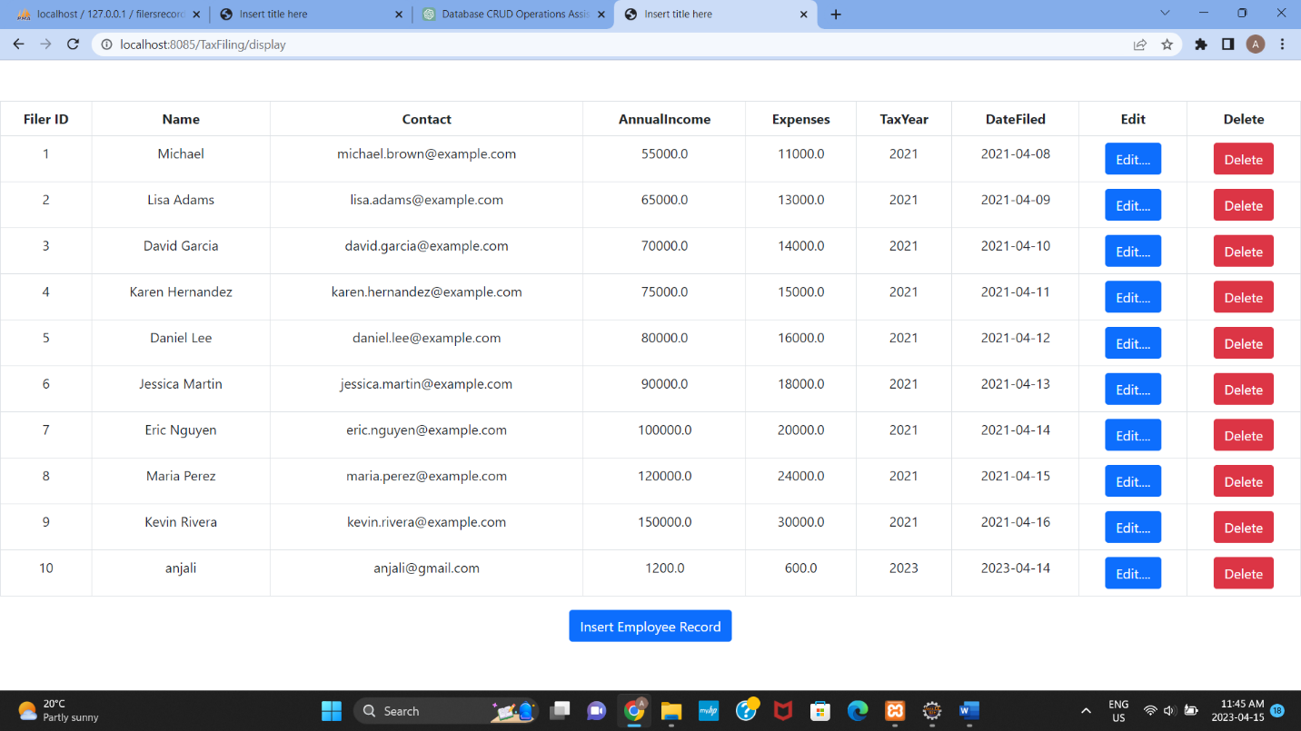 20

c) Add a new Tax Filer Record in to the database using a button on your view page. 20

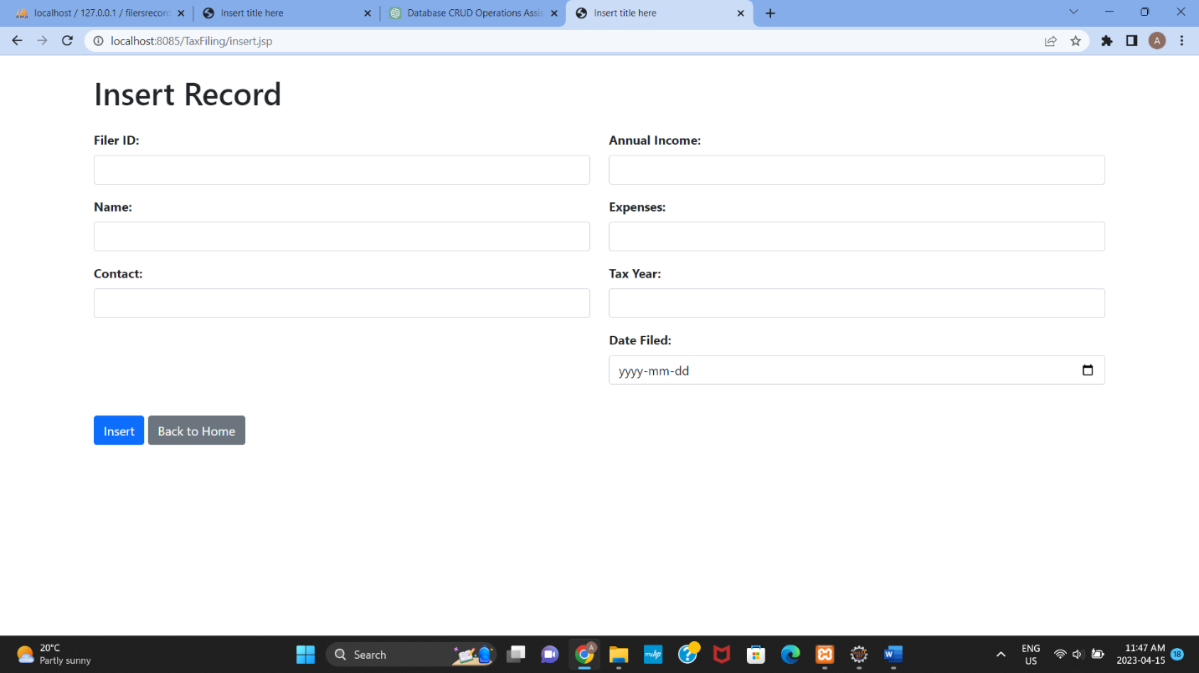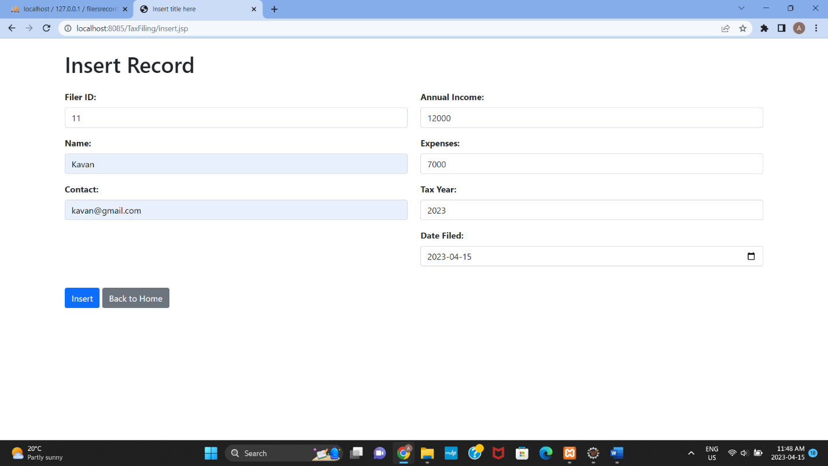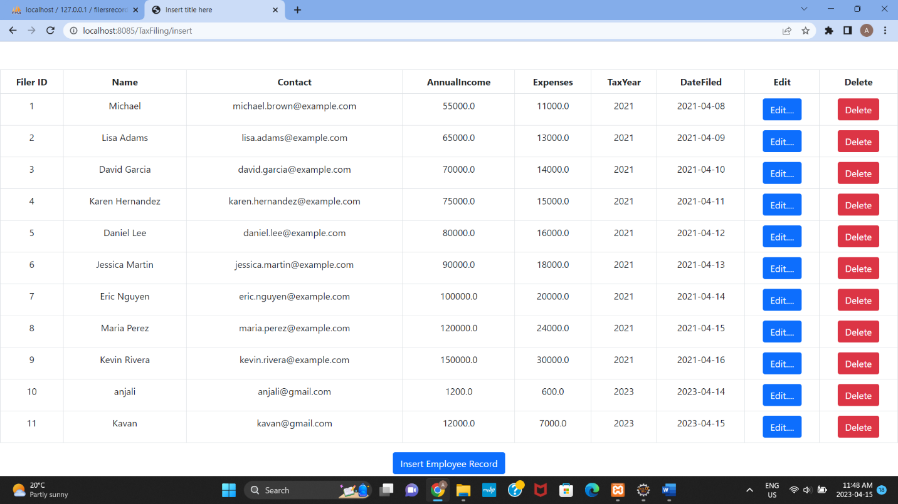

For Duplicate ID:

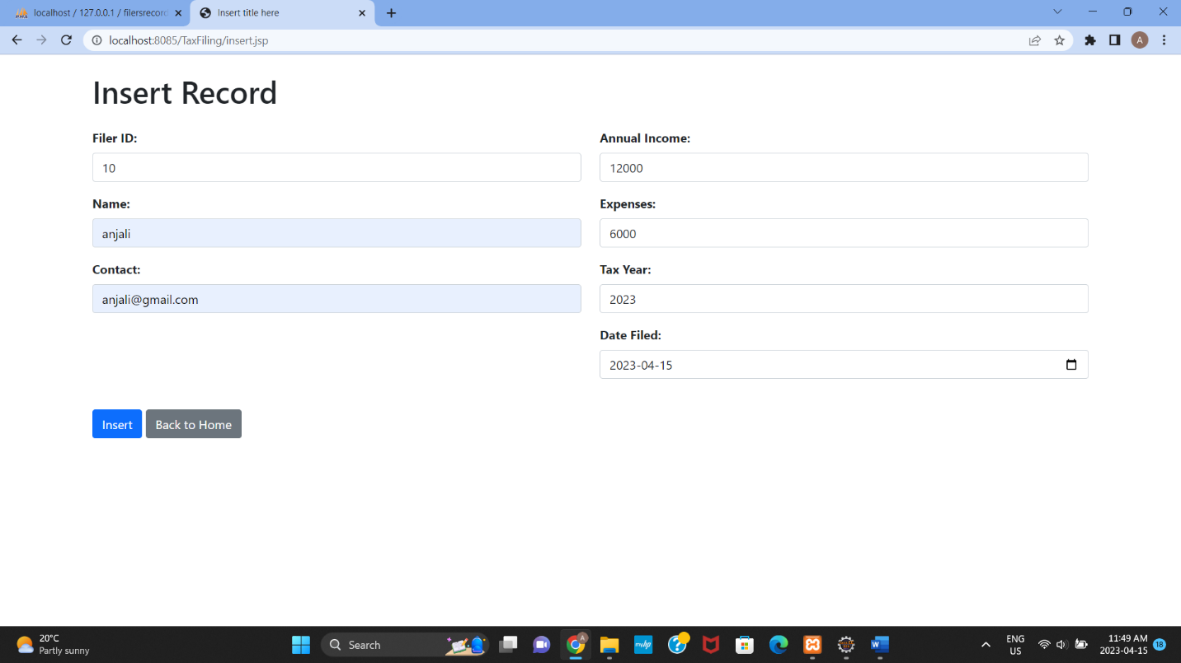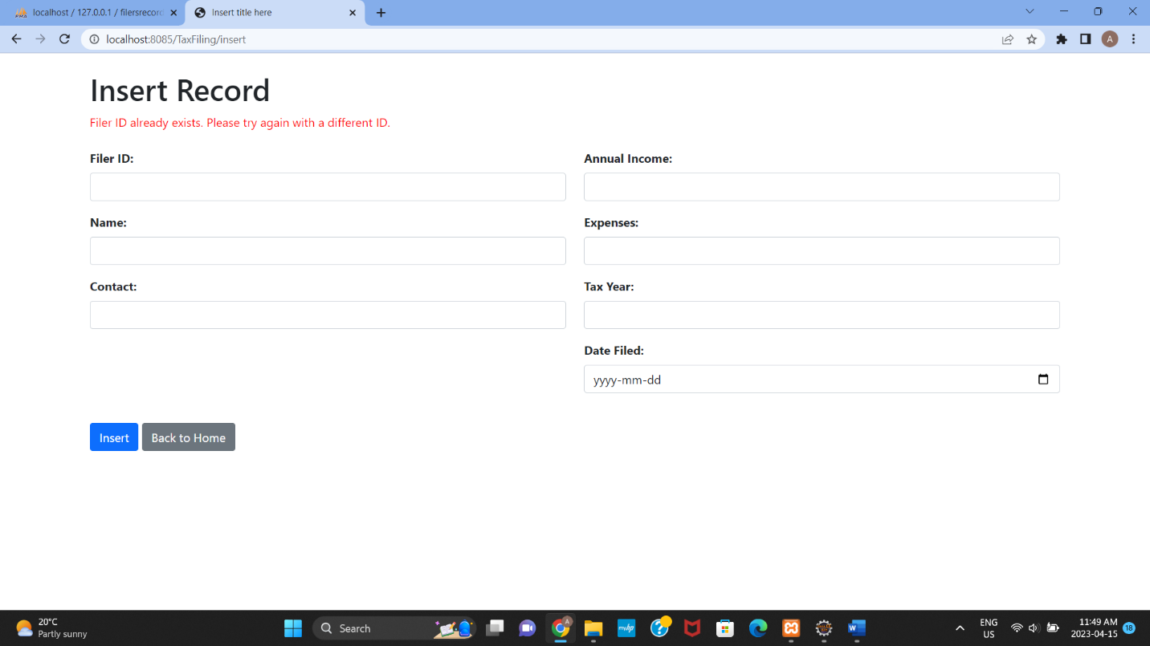

d)Update an existing Tax Filer Record using an Update Button on your view page. 20

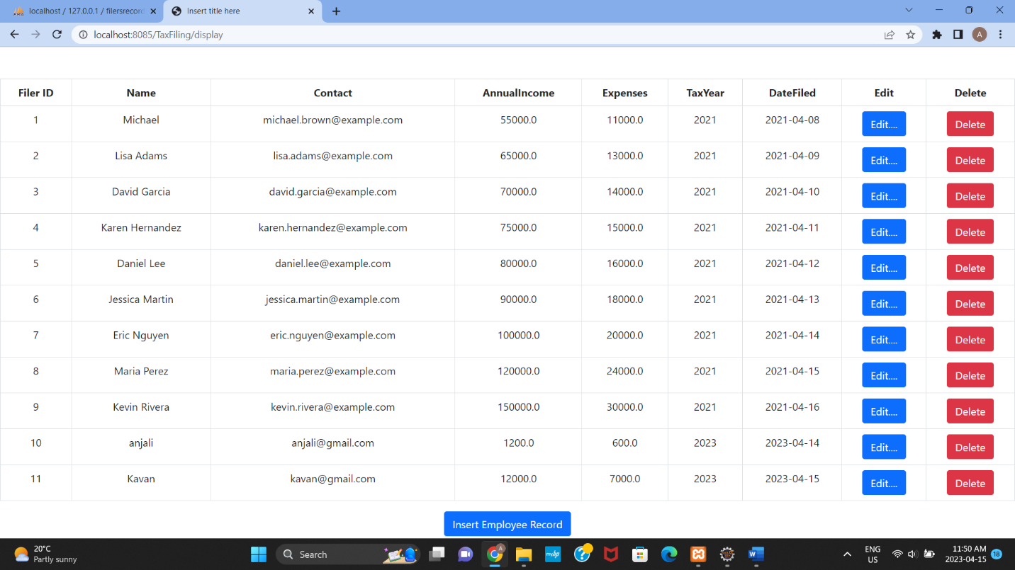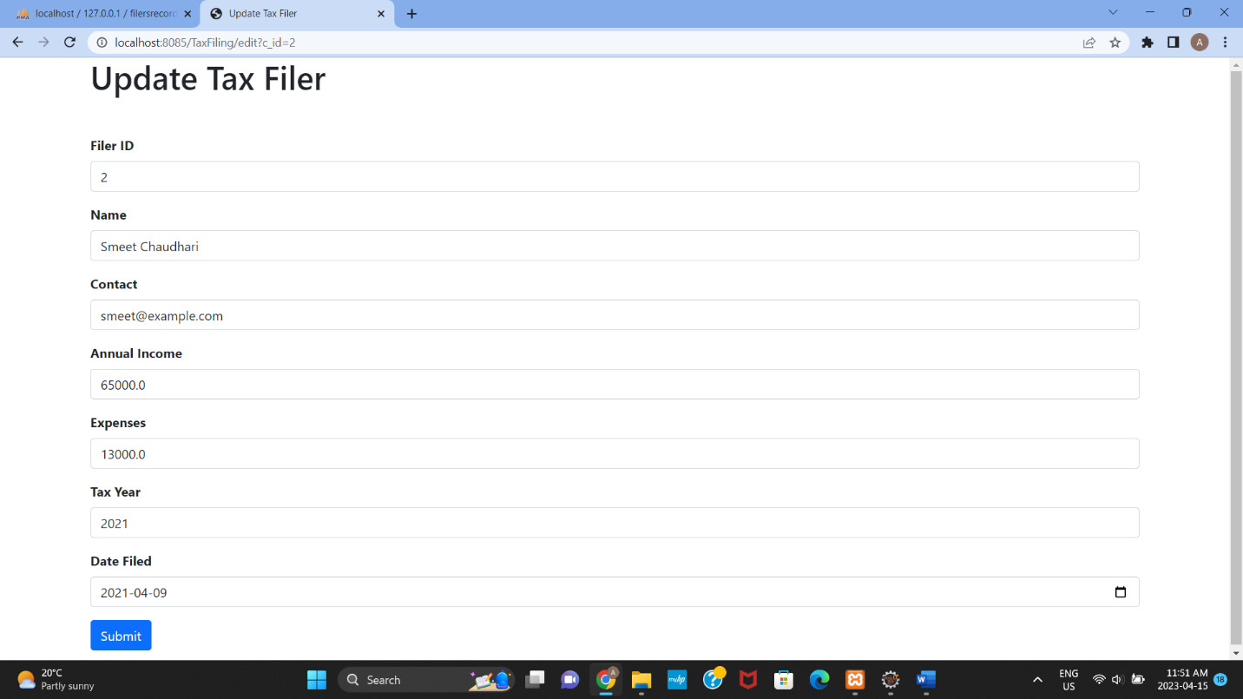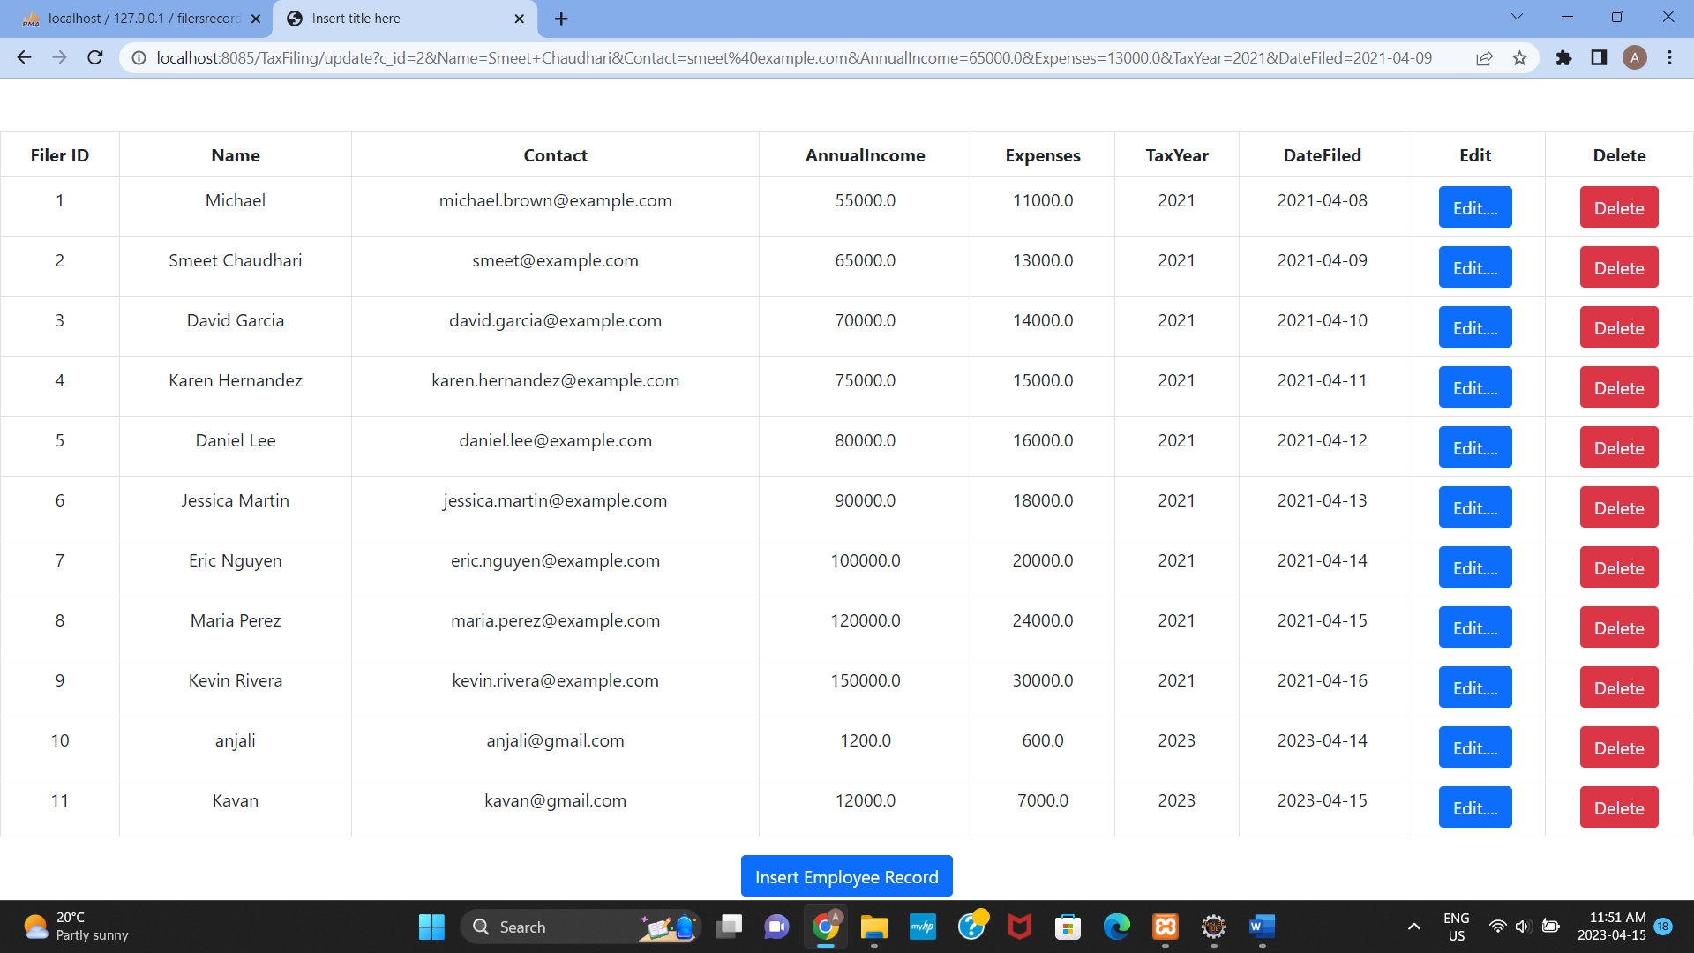

e)Delete a Tax Filer Record using a Delete Button on your view page.

20

Deleting id: 11

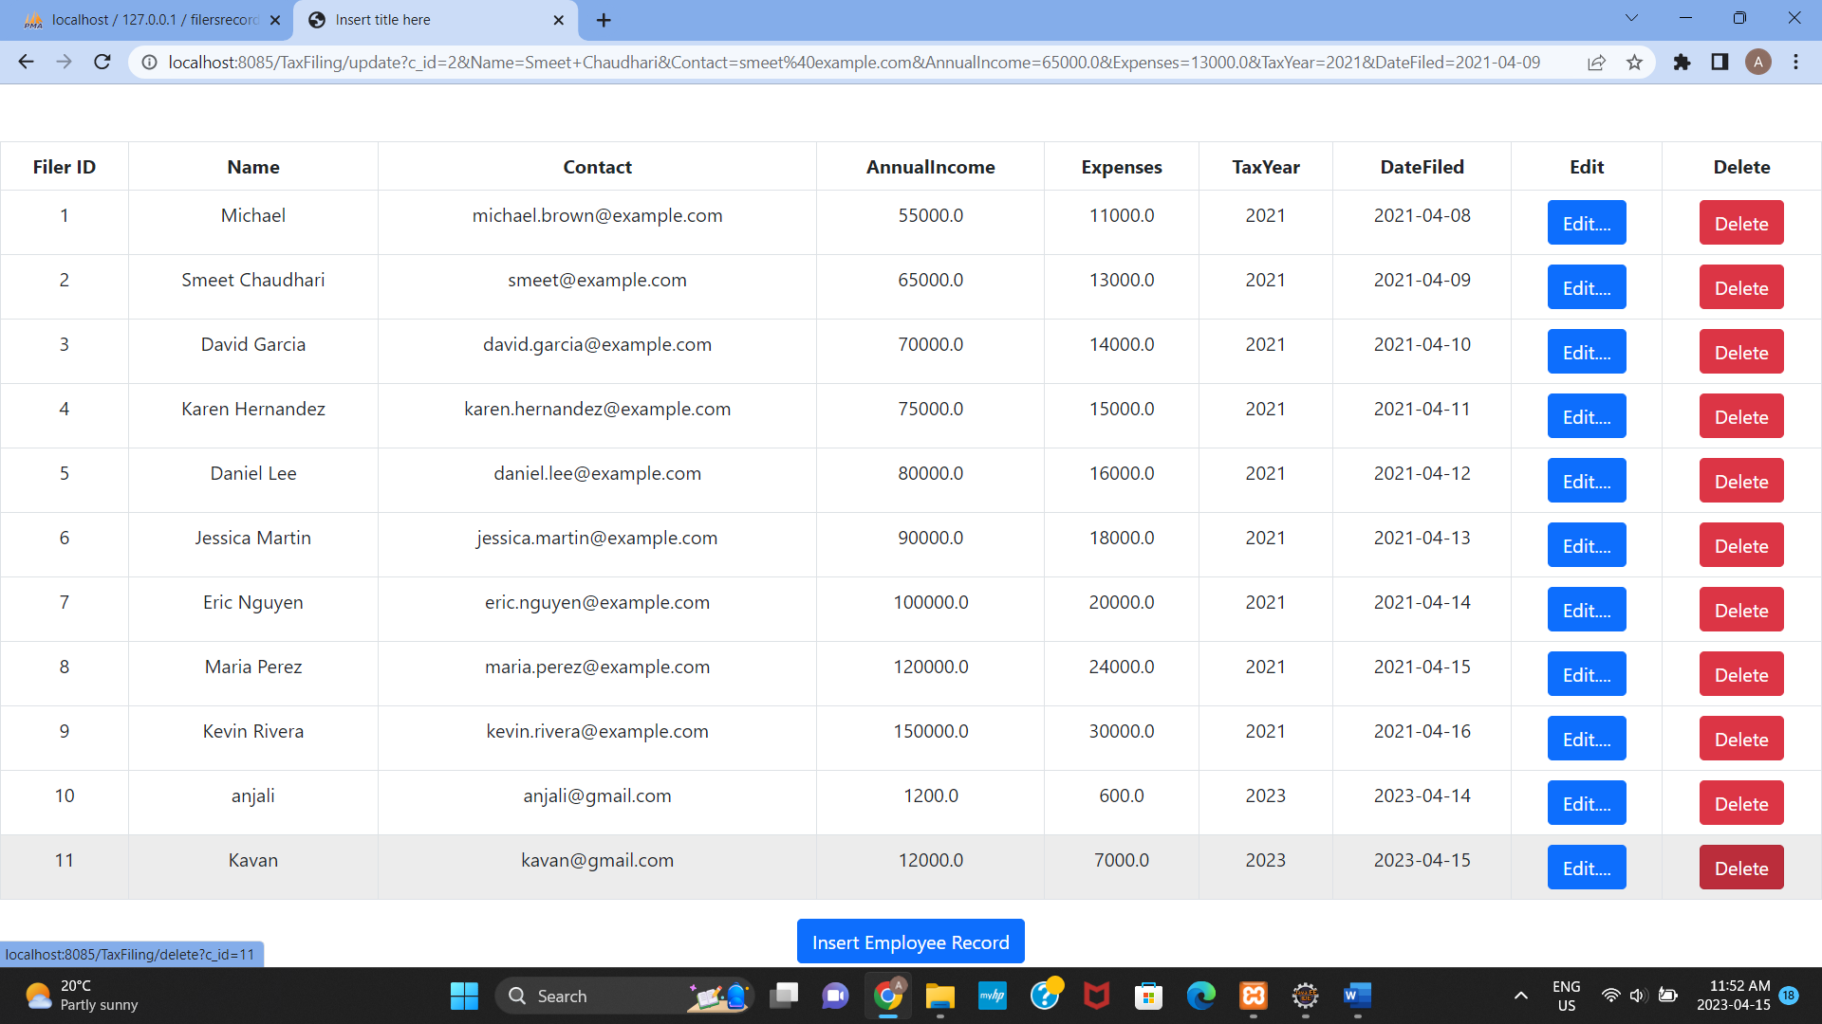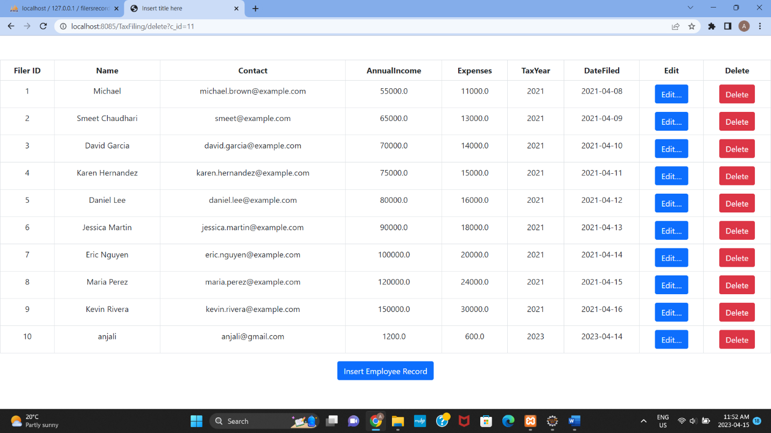

f) Use ManagedBean if using JSF with annotation and create separate DAO class for Crud operations or use a Simple Java Bean as your Model class if using JSPs and Servlets.Try to create separate methods for all crud operations. 10

* TaxFilersDao.java

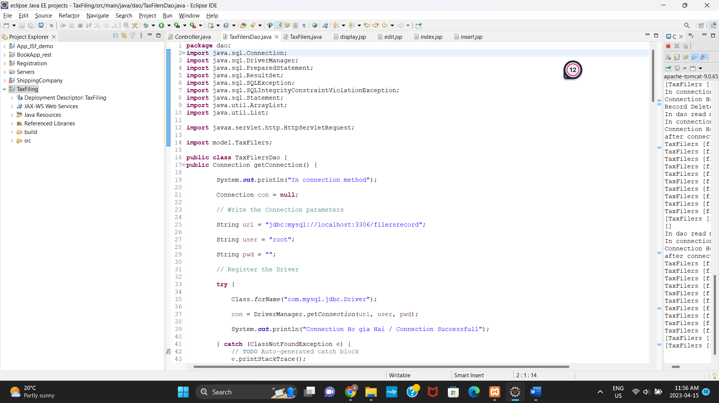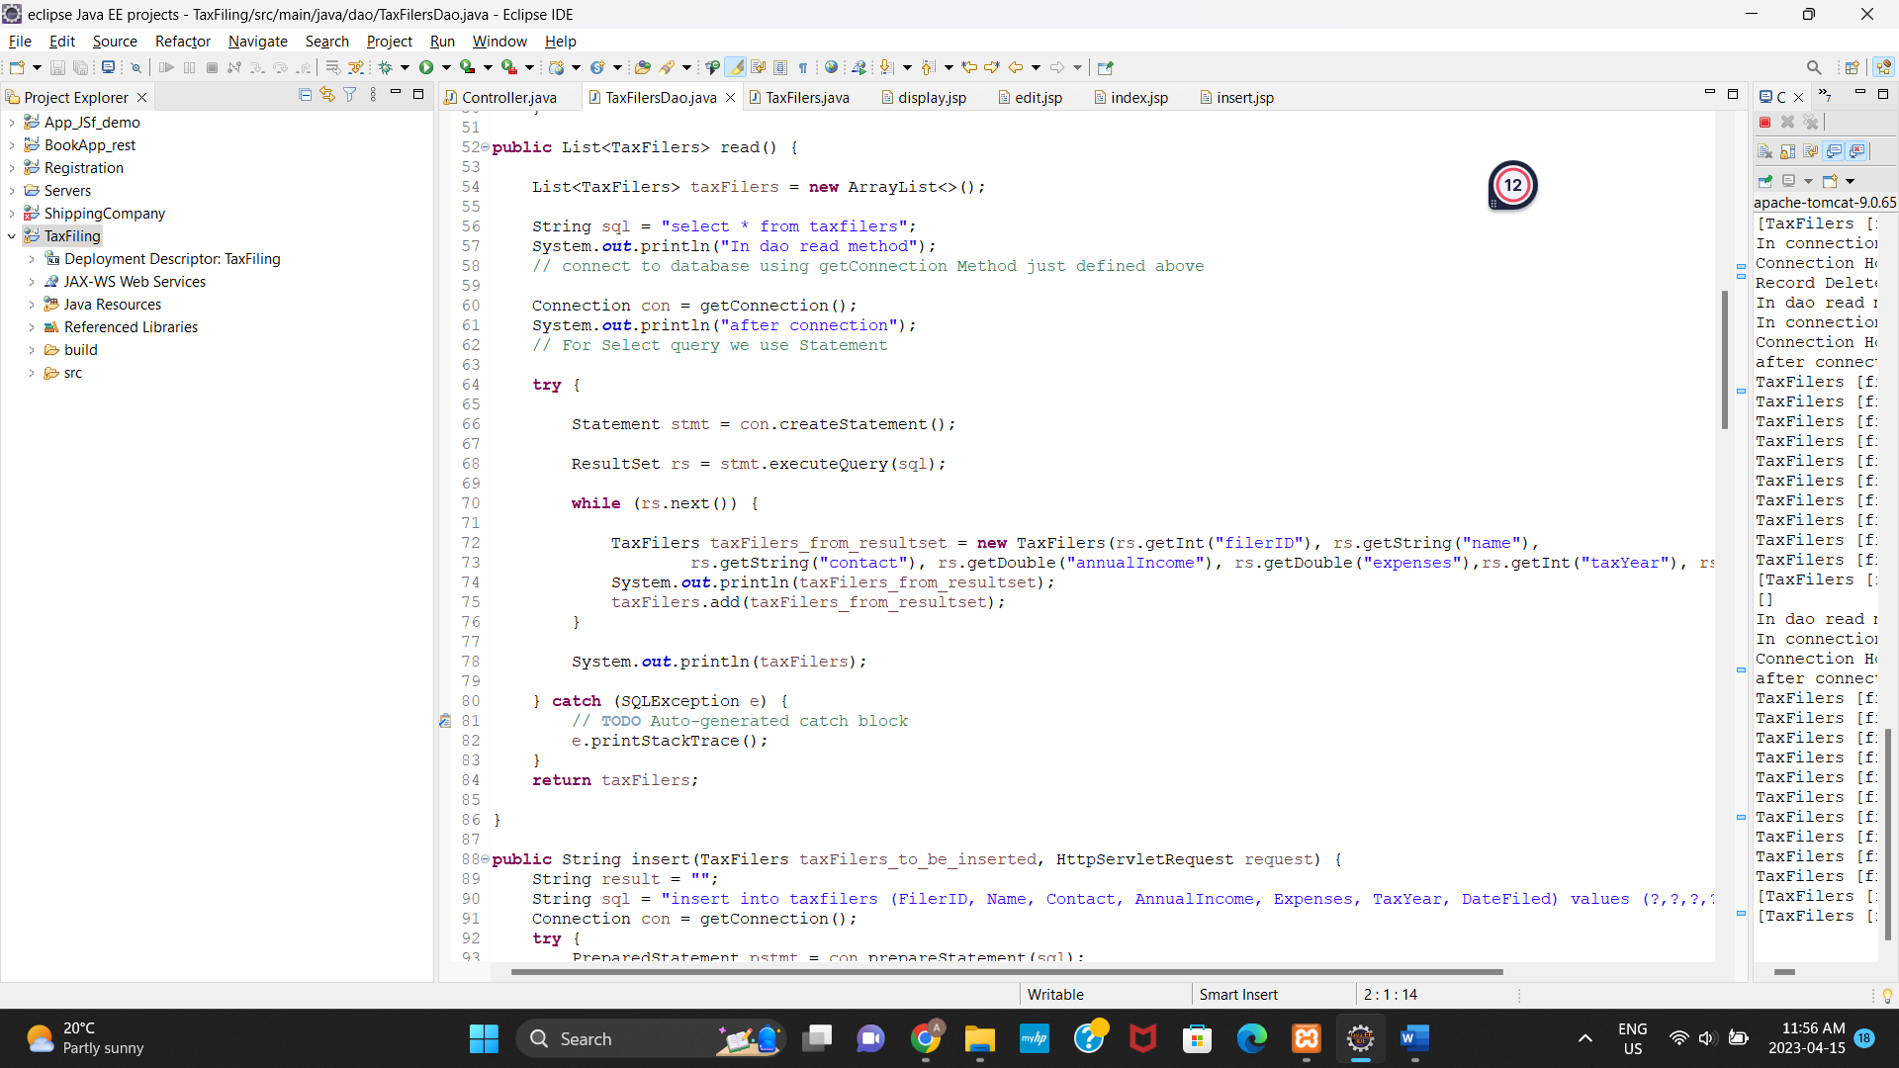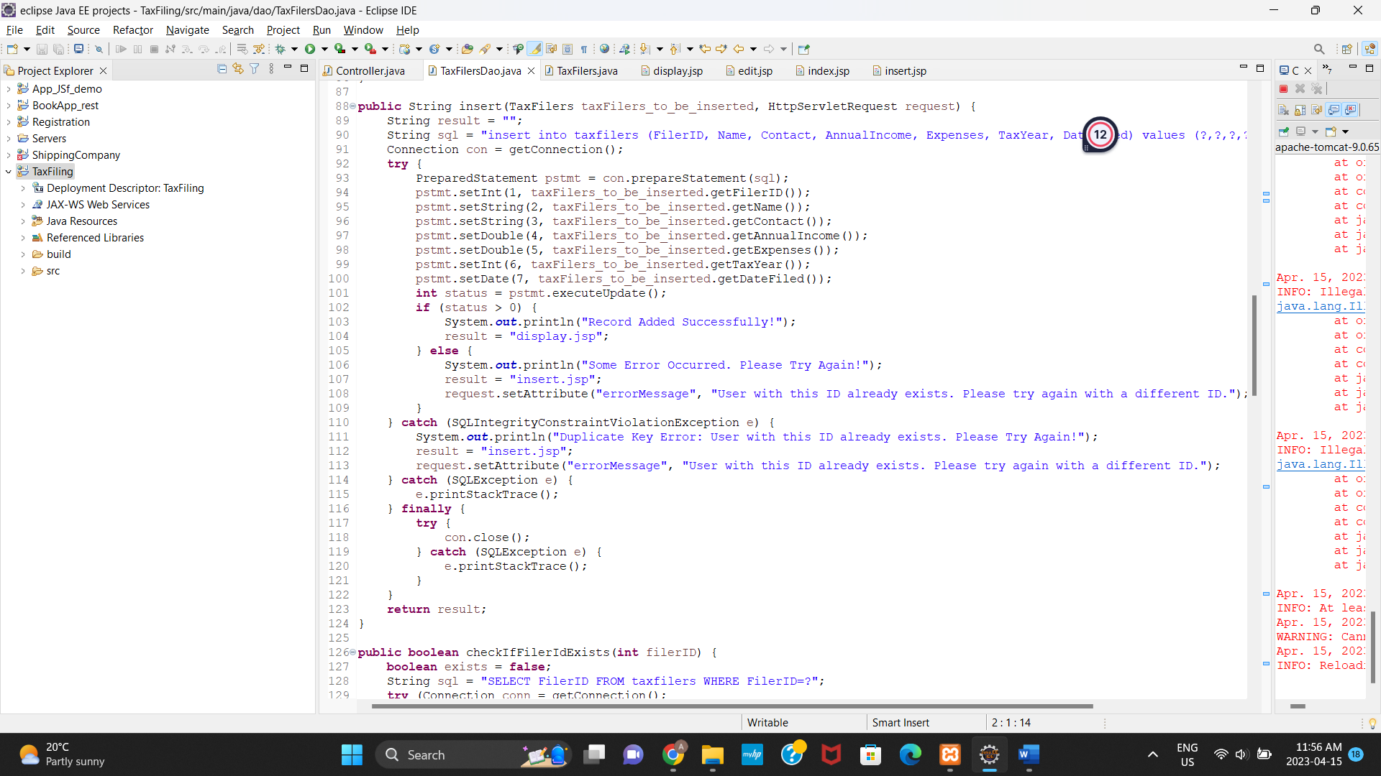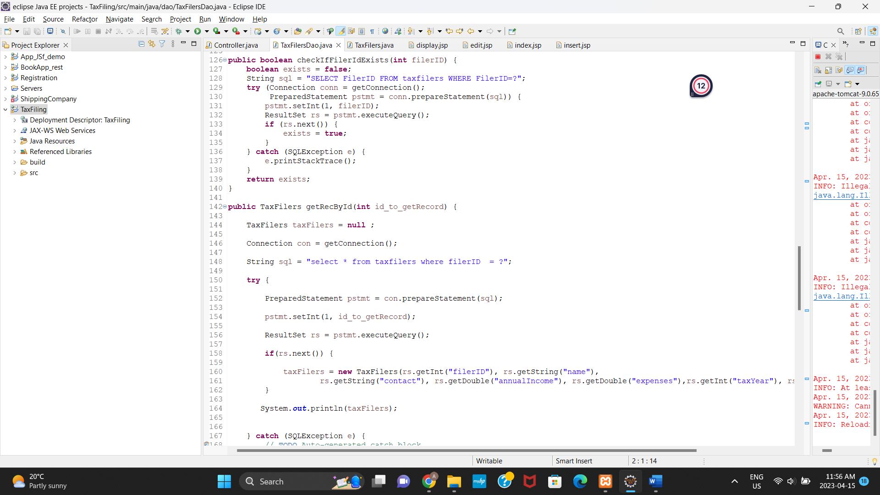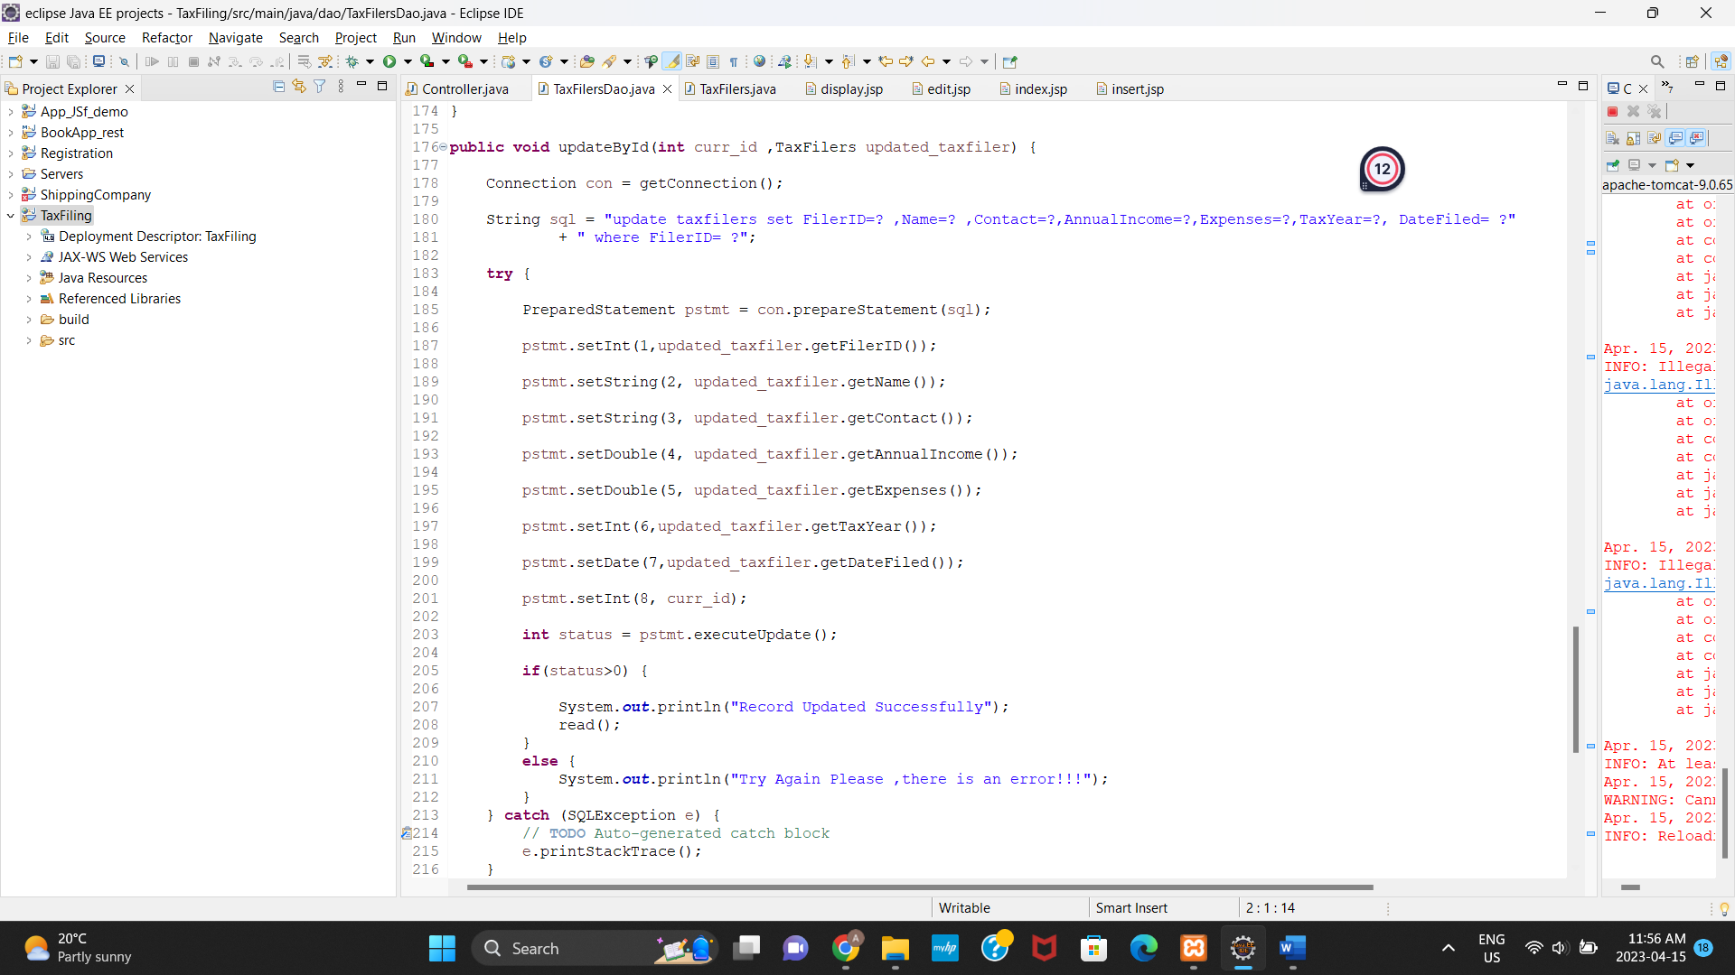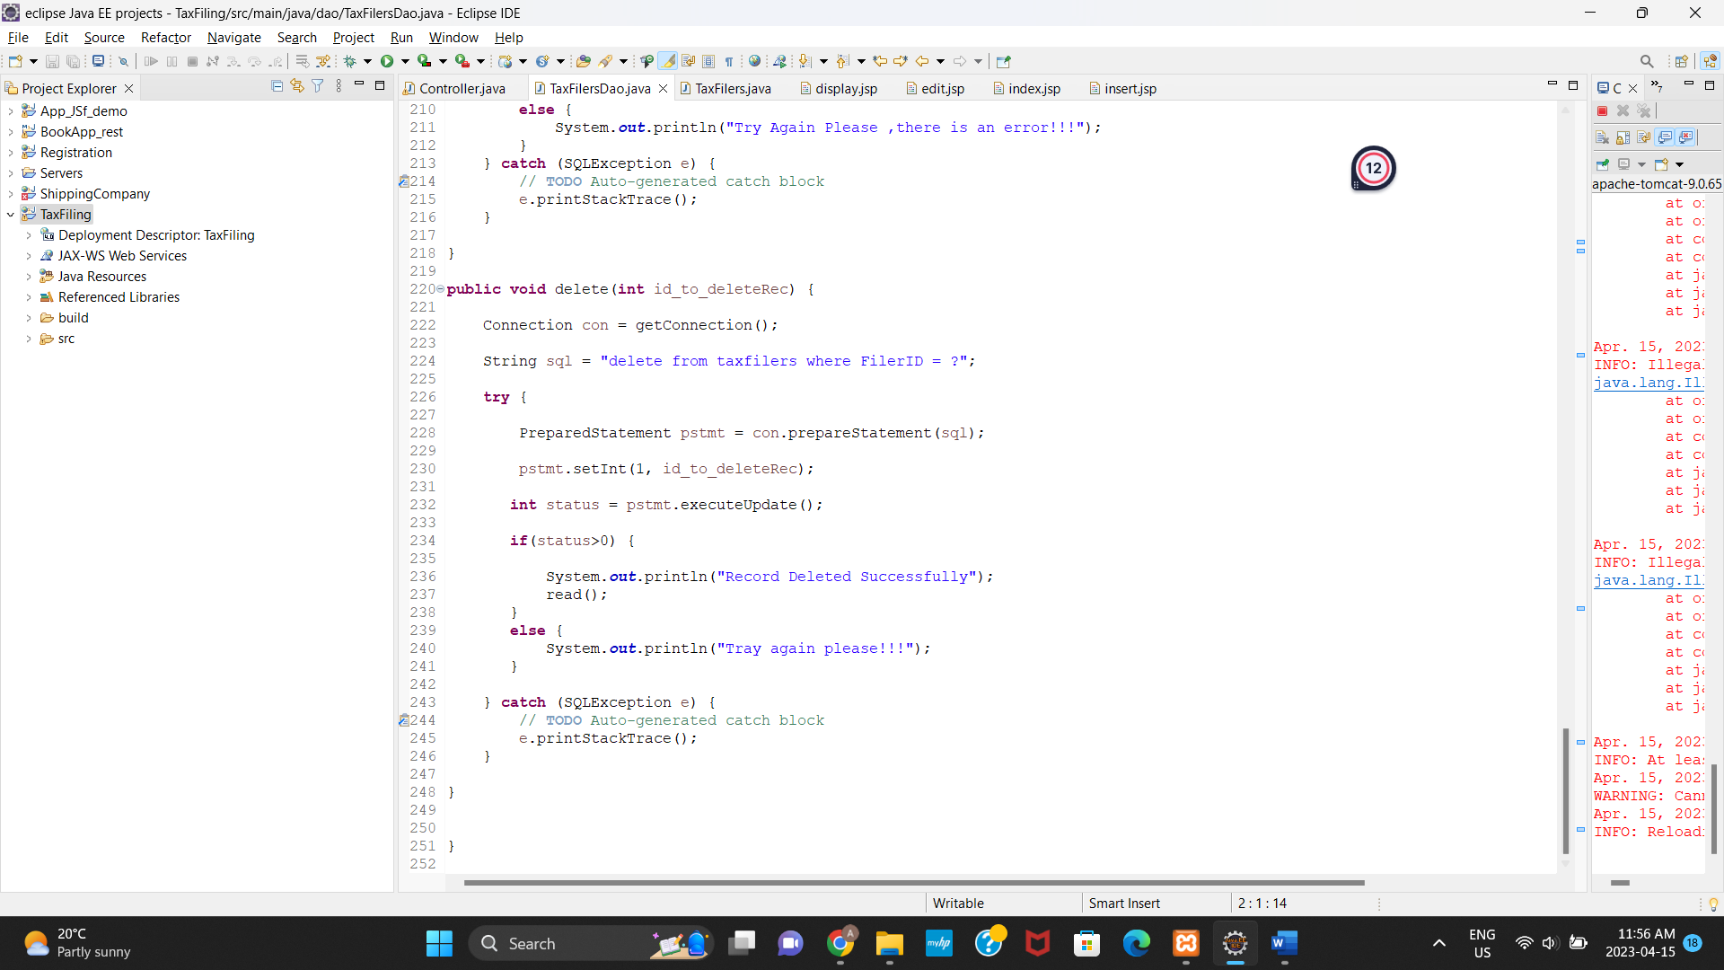

* Controller.java

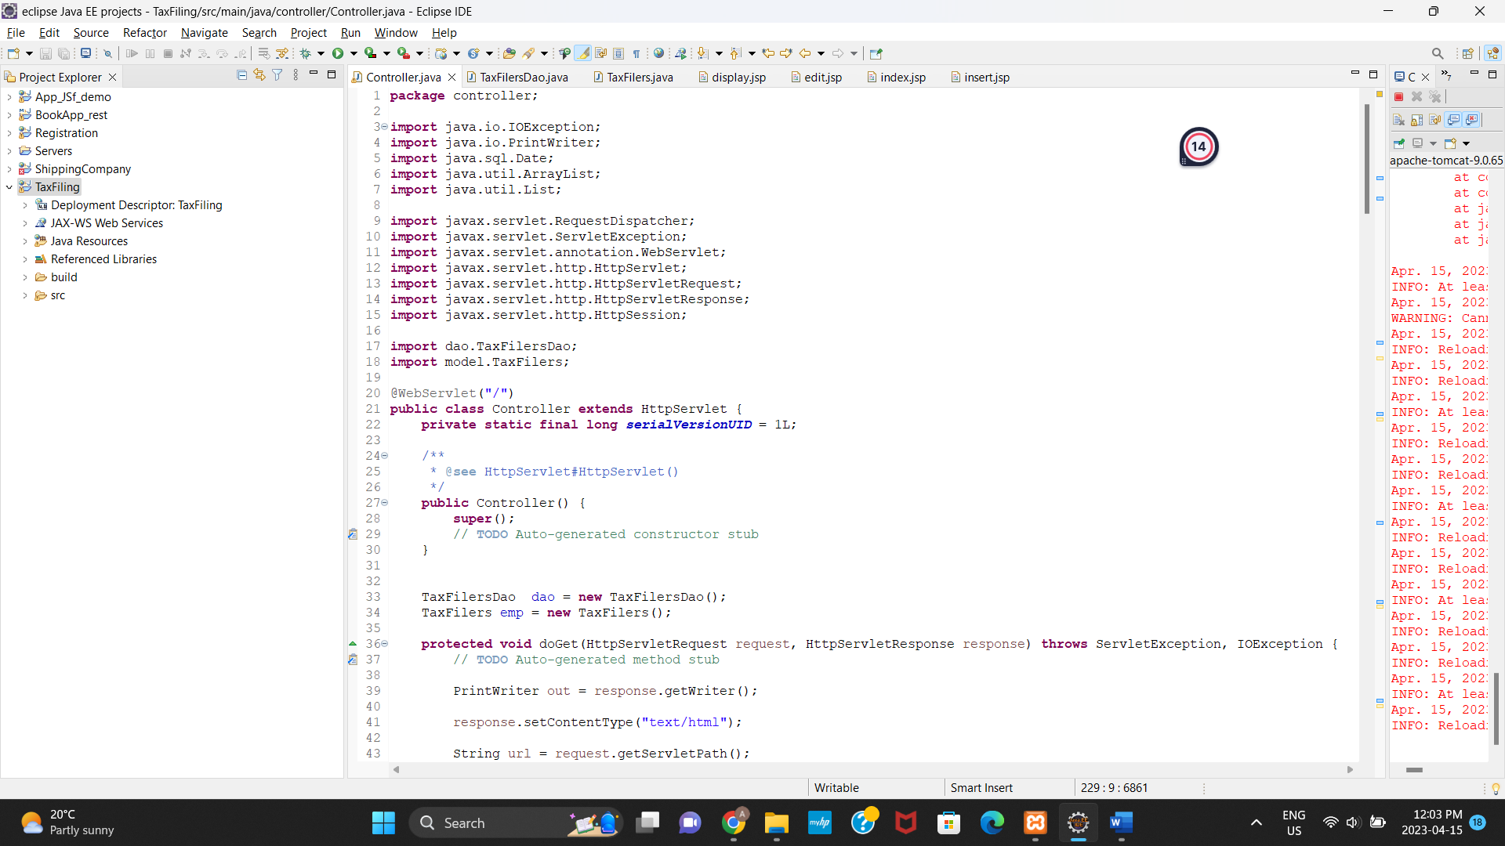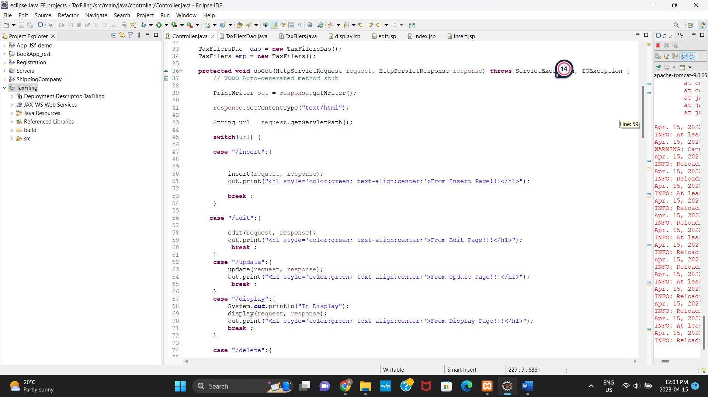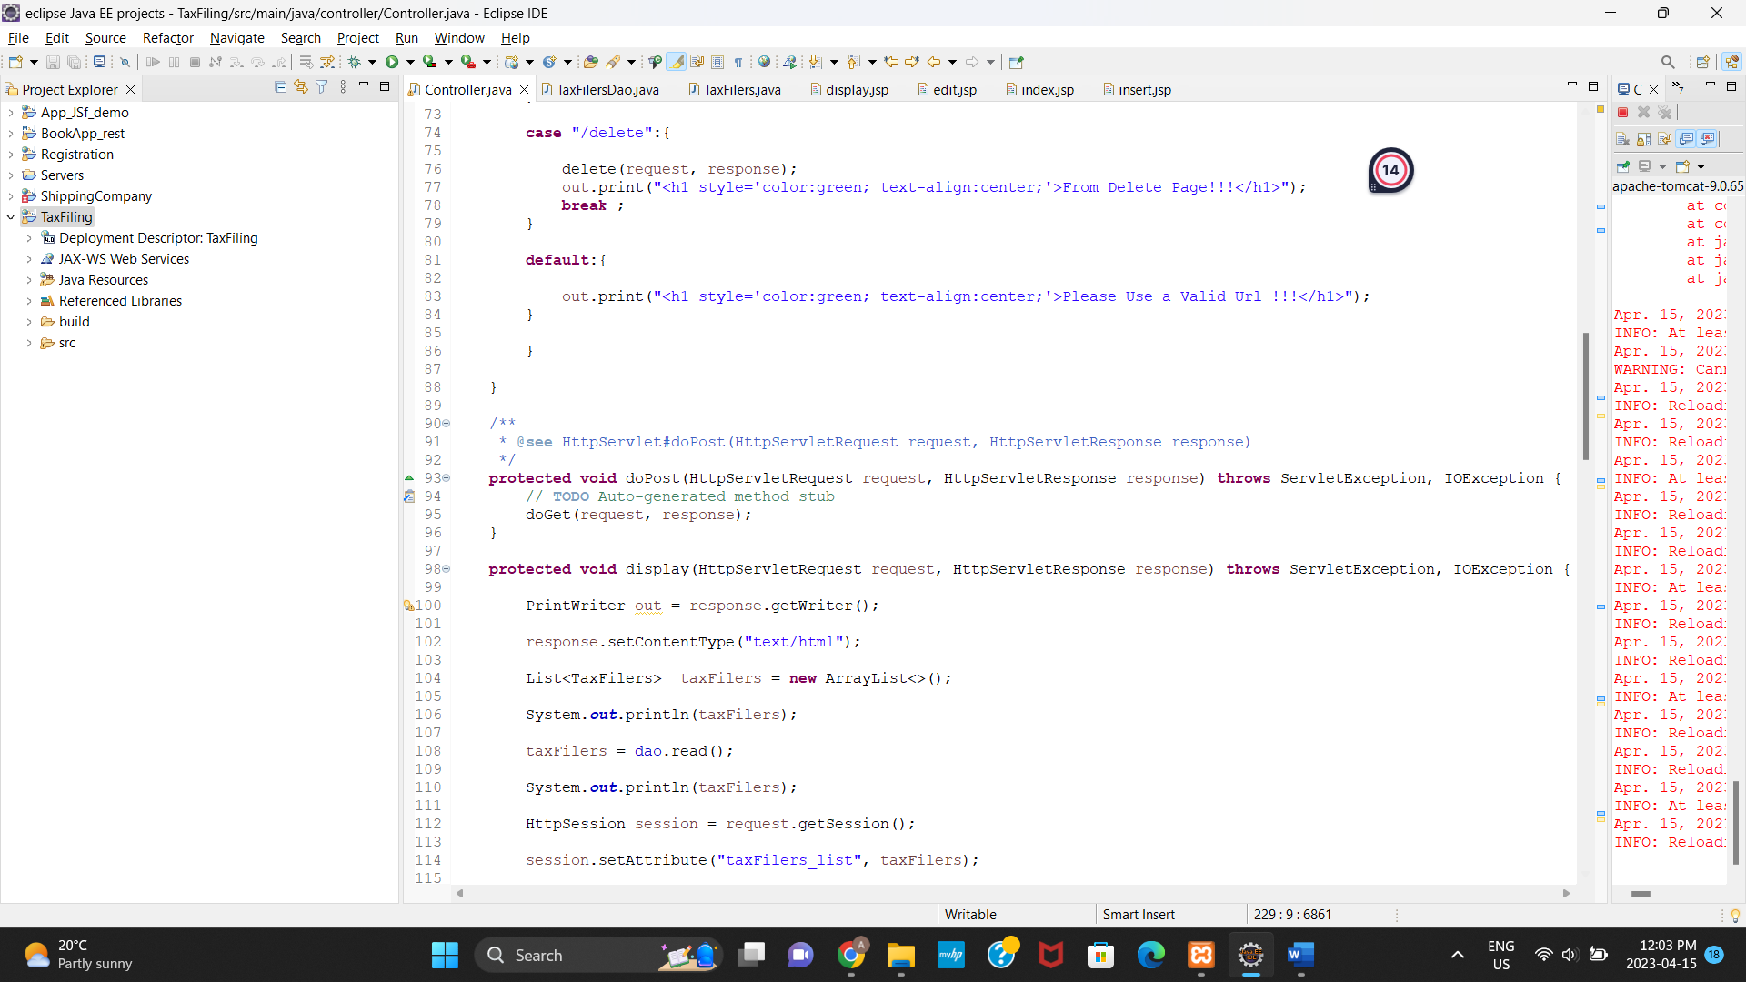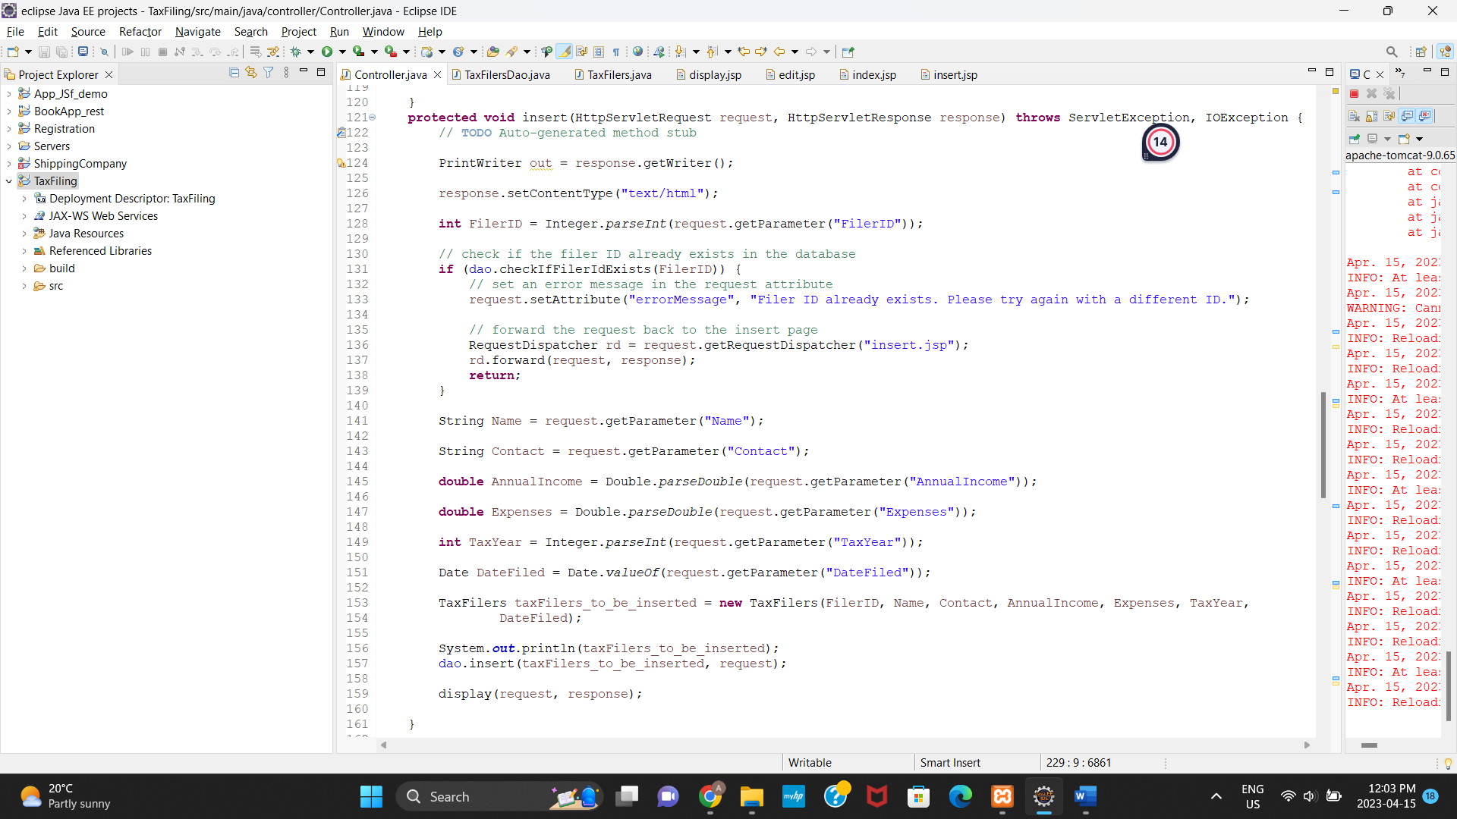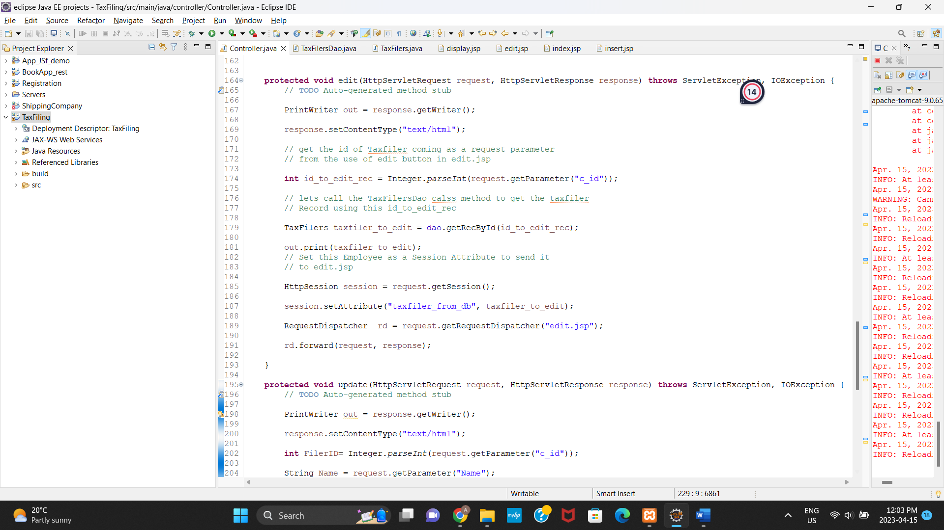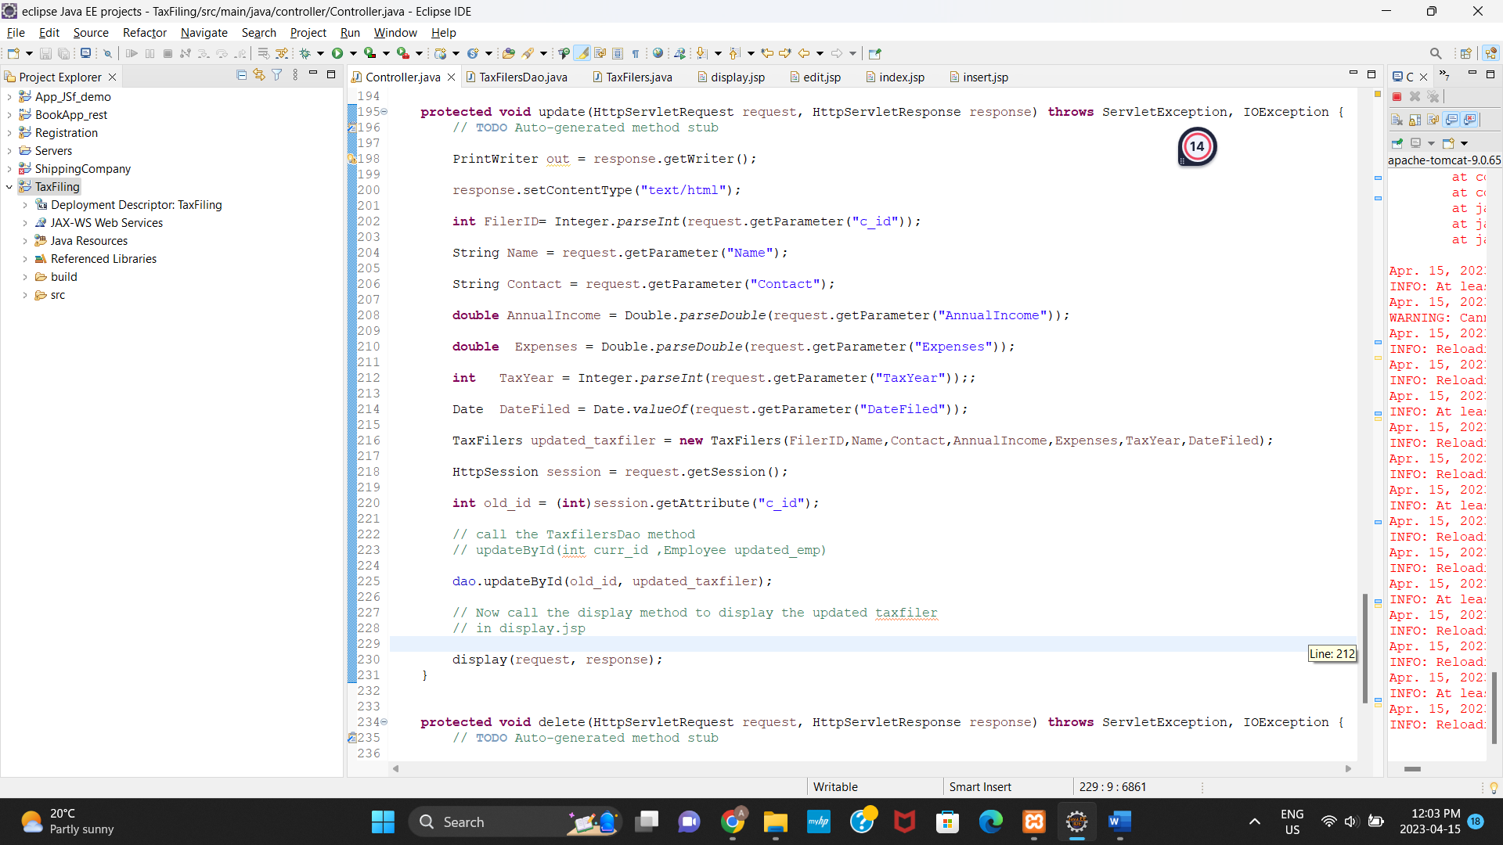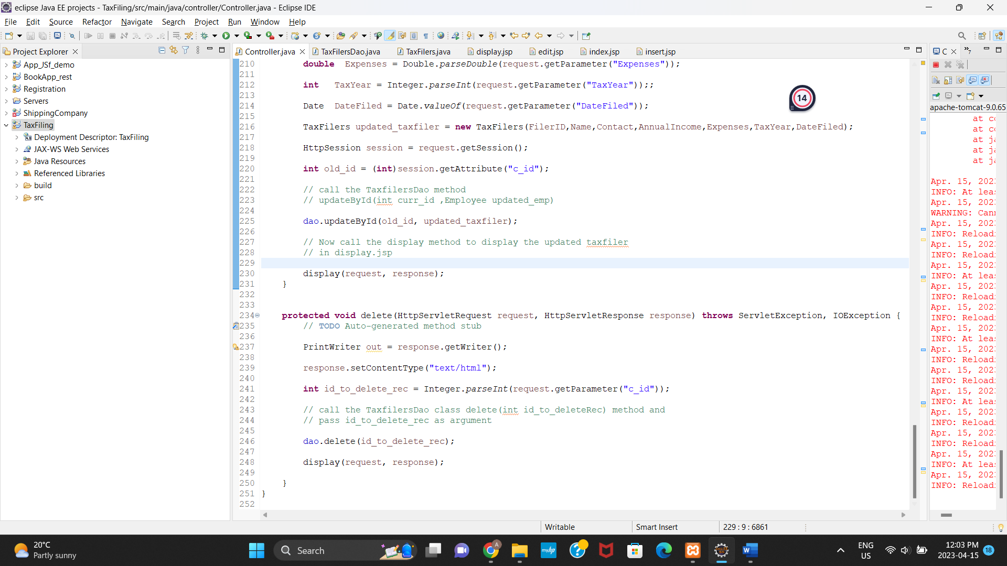

* TaxFilers.java

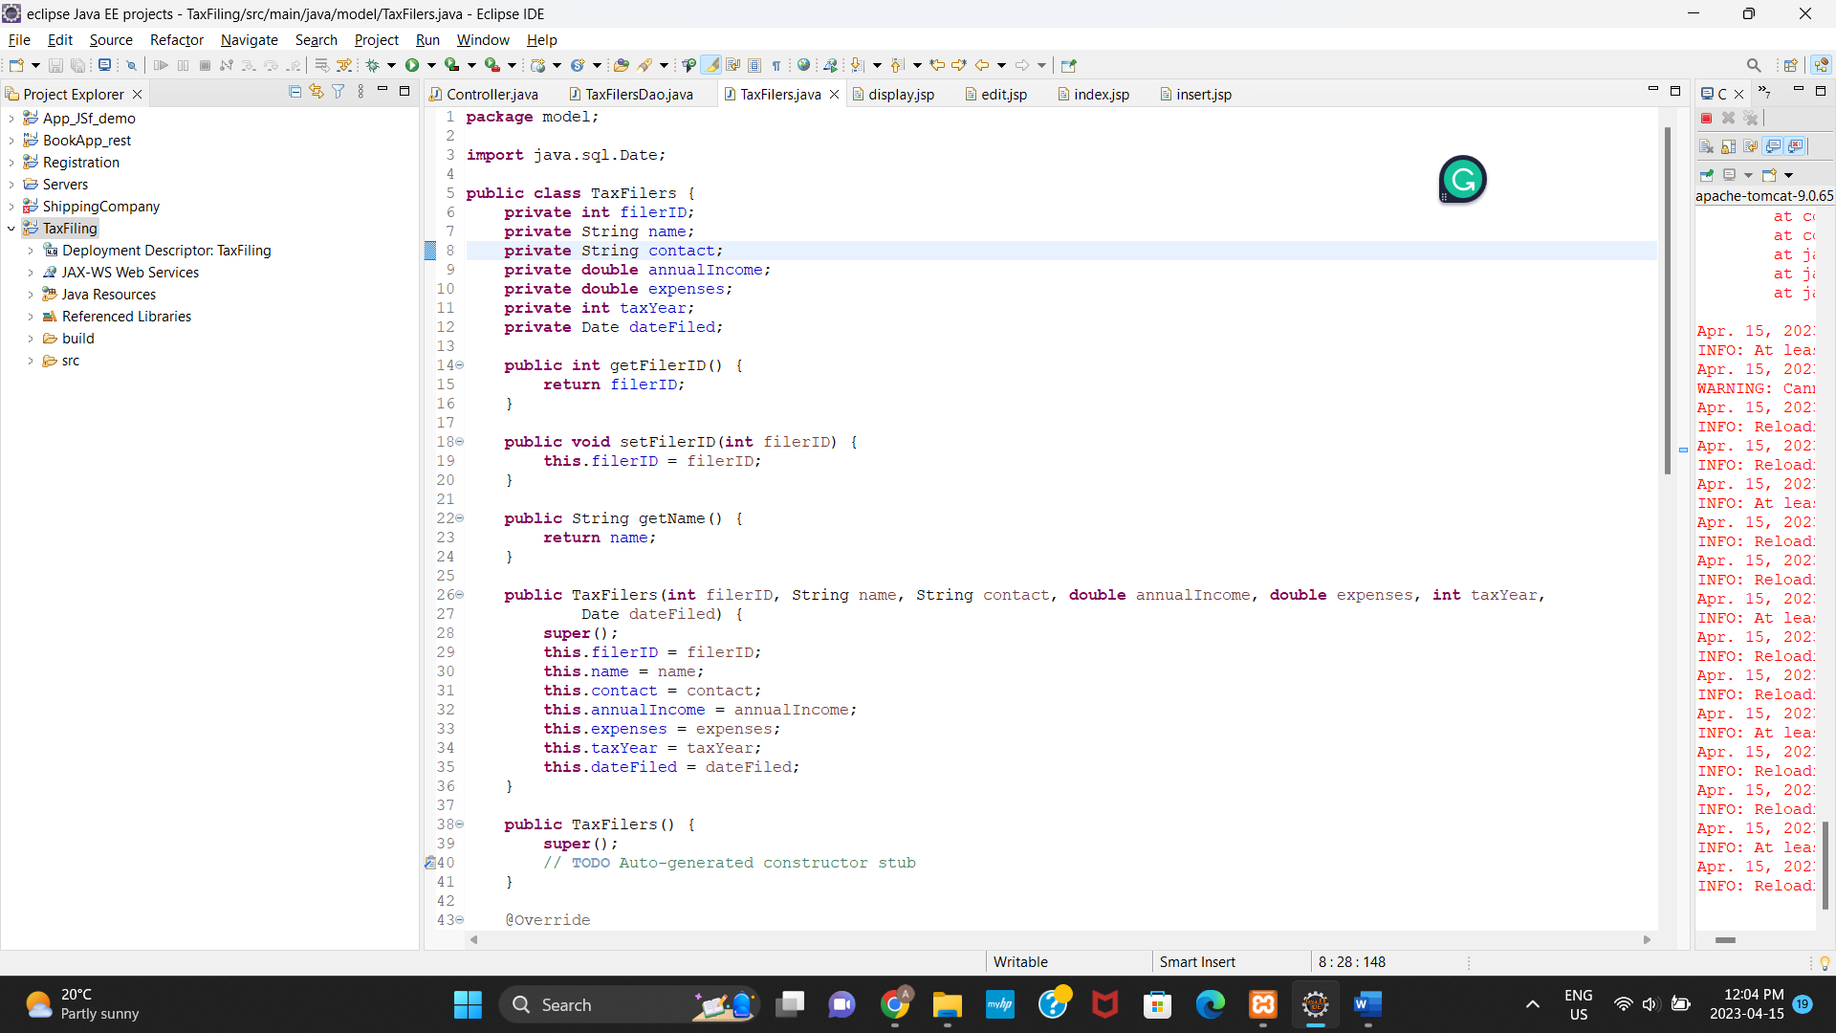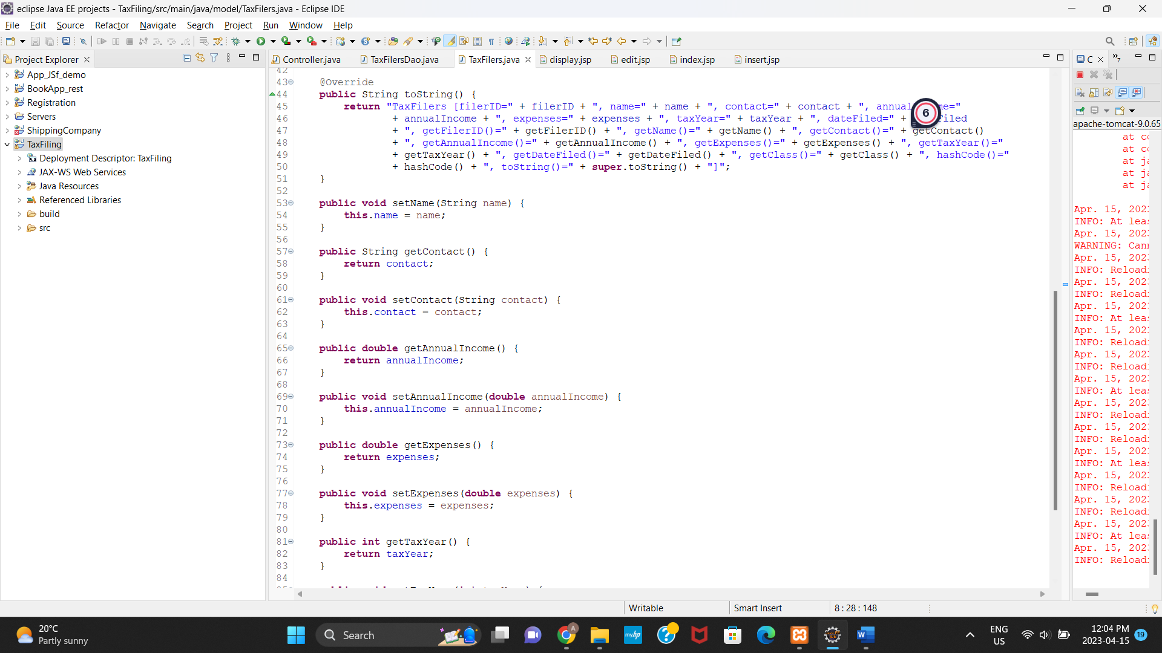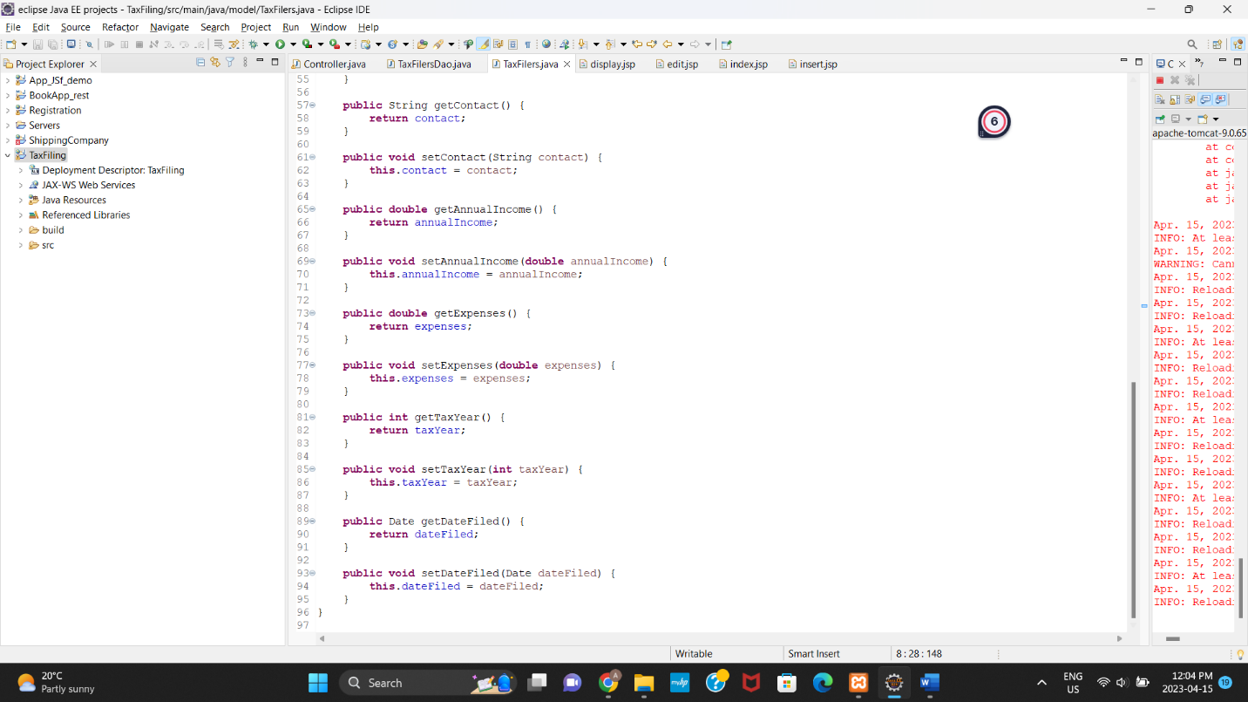

* Display.jsp

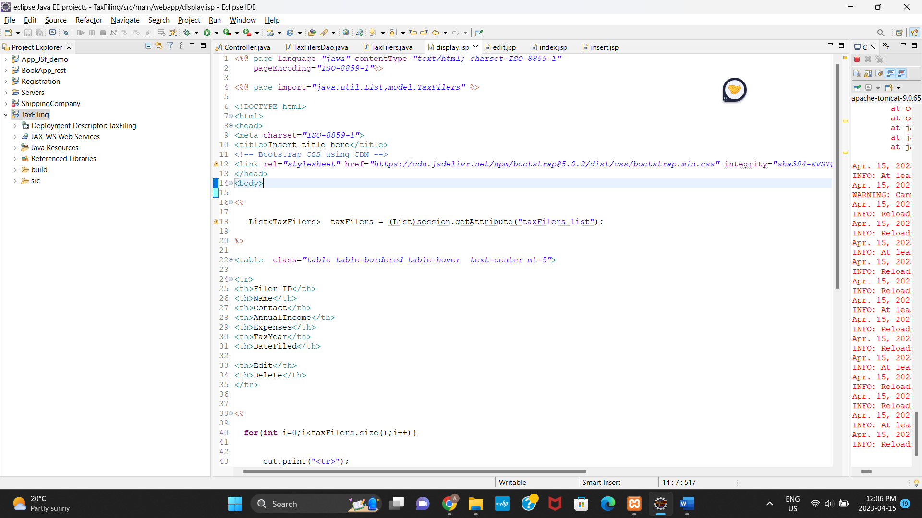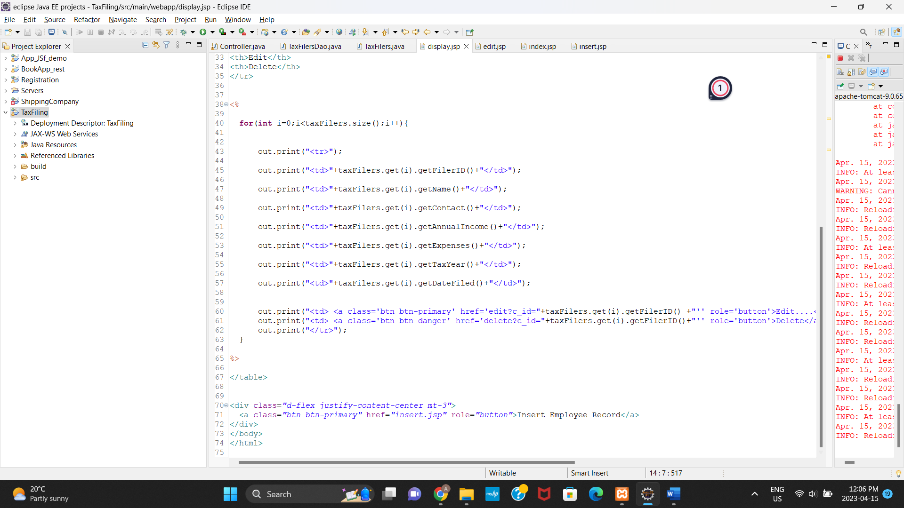

* Edit.jsp

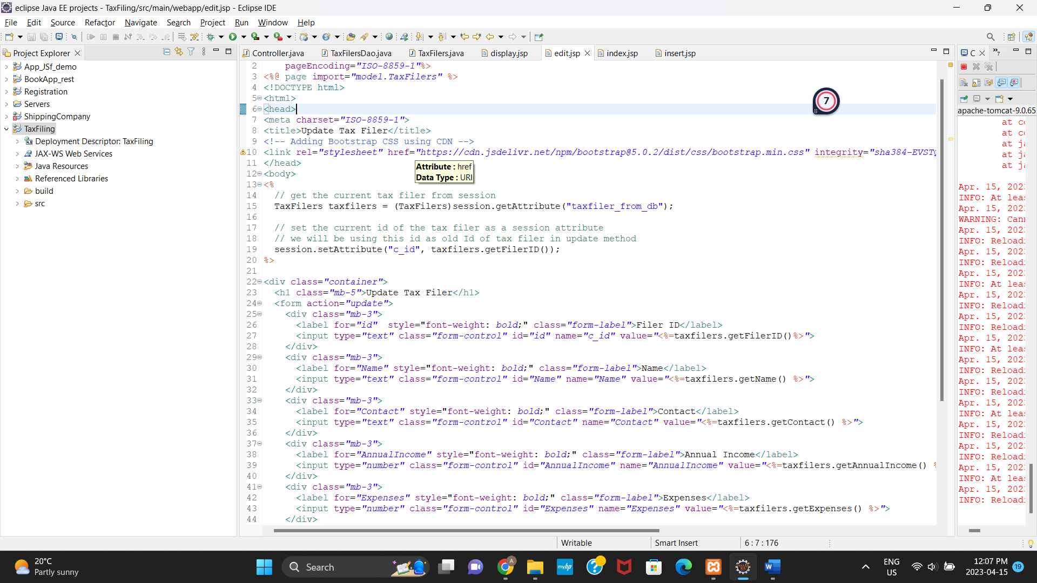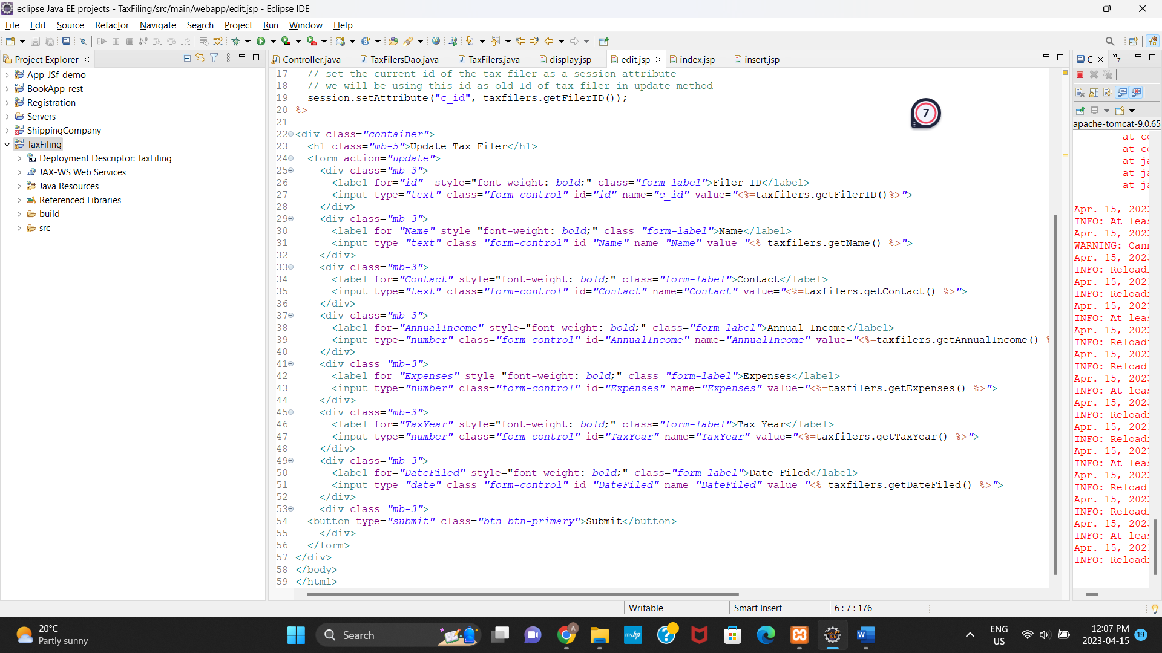

* Index.jsp

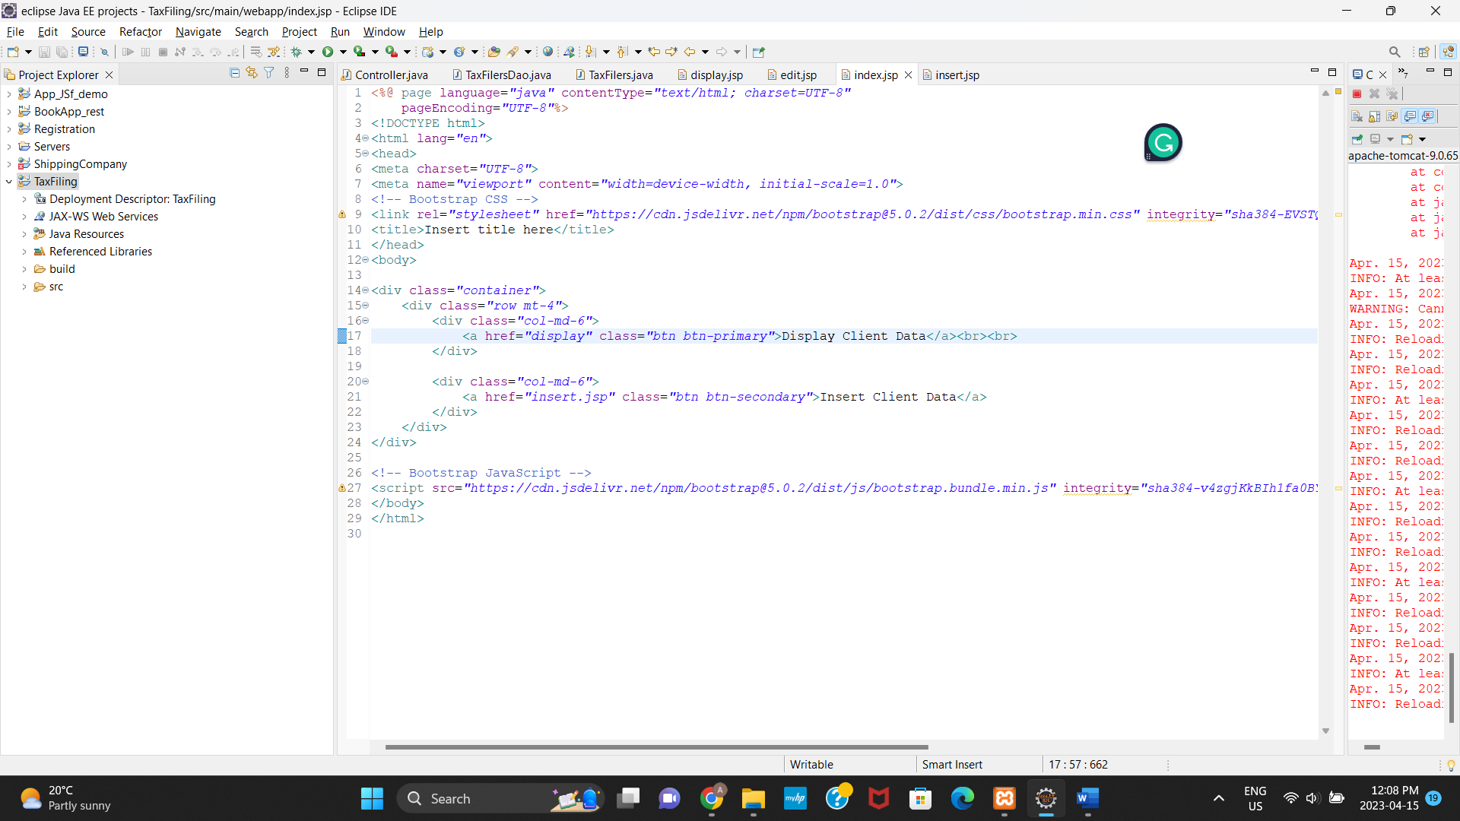

Insert.jsp

